|  |
| --- |
| User Manual |
| GLOBLOCK |
| BSHCE4 NM BSc in Computing |

|  |
| --- |
| Alex Quigley - x10205691  5/19/2014 |

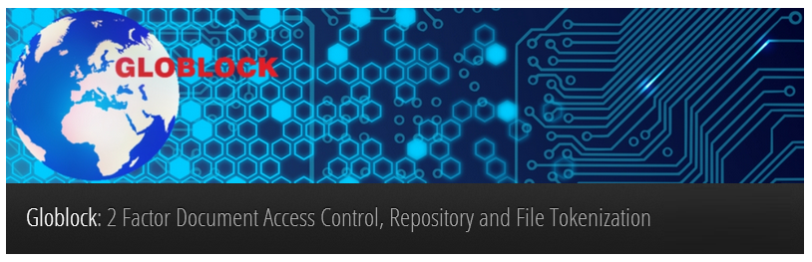

# Document Control

## Project Information

|  |  |
| --- | --- |
| Project Title: | Globlock |
| Course Code: | BSHCE4 |
| Course Title: | BSc (Hons) in Computing |
| Course Specialisation: | Network and Mobile Technologies |
| Student Name: | Alex Quigley |
| Student Number: | 10205691 |
| Date: | 19th May 2014 |

## Project Information

|  |  |  |  |
| --- | --- | --- | --- |
| Version | Scope | Prepared | Date |
| 1.01 | Create | Alex Quigley | 19th May 2014 |

## Distribution

|  |  |  |  |
| --- | --- | --- | --- |
| Name | Title | Version | Date |
| Paul Hayes | Project Supervisor | 1.01 |  |
| Jonathan McCarthy | Module Co-Ordinator | 1.01 |  |

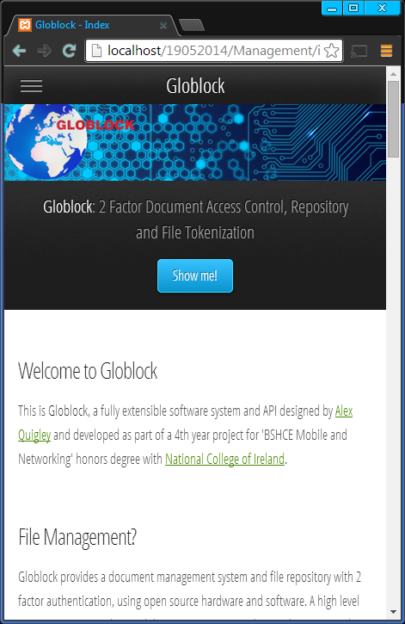

Contents

Document Control 1

Project Information 1

Project Information 1

Distribution 1

Executive Summary 3

Introduction 4

System Features 4

Features Overview 4

Client Login 5

Client Running 5

Listening State 5

Files Found 6

Files Not found 6

Management Web Application 7

Globes 7

Documents 7

Groups 8

Users 8

# Executive Summary

Repositories are often very complicated to use for untrained or unskilled professionals. They come with a large overheard, and require a significant amount of time to implement and use. Repositories have been part and parcel of the development environment since revision and historical code management become standard practice.

It is clear that the benefits of a repository, holds value in any organisation and not just at a development level. Repositories come at a cost. The cost is an additional layer of complexity and the requirement for implementation and maintenance on the system.

Without a repository, there can be many different versions of documents. Multiple uncontrolled revisions with changes overlapping and causing confusion, risk and loss, can lead to a very costly experience.

Globlock is the solution that takes away the difficulty and complication by providing a facility for documents to be managed and archived, securely, secretly and successfully, will little or no requirement for tacit knowledge of complicated repository systems.

Added to this the concurrent access controls which prevent multiple version being accessed and edited by multiple users.

The system itself is intuitive, and provides an abstraction of the documents by giving them a physical form. This allows users of the system to feel as if the object in their hand contains the files, instead of the system that it is used with.

This feeling carries weight in the real world and the physical hand over of a document or group of documents is no longer a part of the working environment.

# Introduction

This document is a deliverable for a final year project as part of an Honours Degree in computing with the National College of Ireland.

This document is a User Manual for the Globlock project.

# System Features

### Features Overview

Below is a brief overview of the system features. See Appendix of SRS document for full Use Case Diagram.

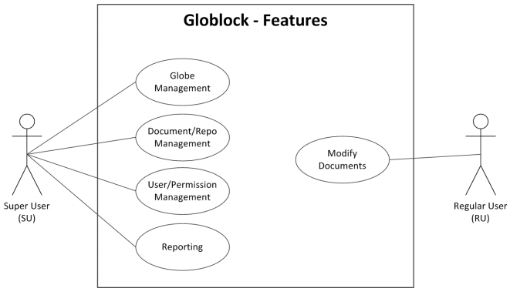

Figure 1

### Client Login

Enter your assigned username and password.

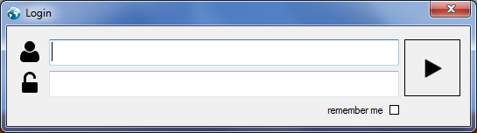

Figure 2

### Client Running

When you see the message below, it means the system is working. You may now right click the Globlock icon in the taskbar and select listen.

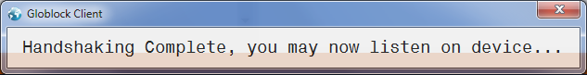

Figure 3

When the device is ready, it will prompt you with a message.

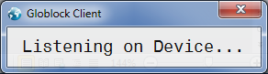

Figure 4

### Listening State

Now that the device is in a listening state, you may swipe/ move your globe object over the device. This will activate the RFID sensor.



### Files Found

If the system has found files on the server it will respond with a message similar to below.



Figure 5

### Files Not found

If you are a super user, and a globe project has not been associated with the object on the system, you will be prompted with a messagebox;

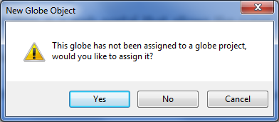

Figure 6

If you choose yes to this messagebox you will be prompted with another window, with a selection choice as per below;

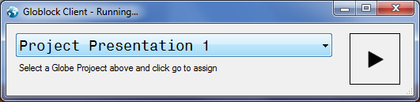

Figure 7

Simply choose a project that you wish to assign to the globe object from the dropdown list provided, or close the window to cancel.

## Management Web Application

 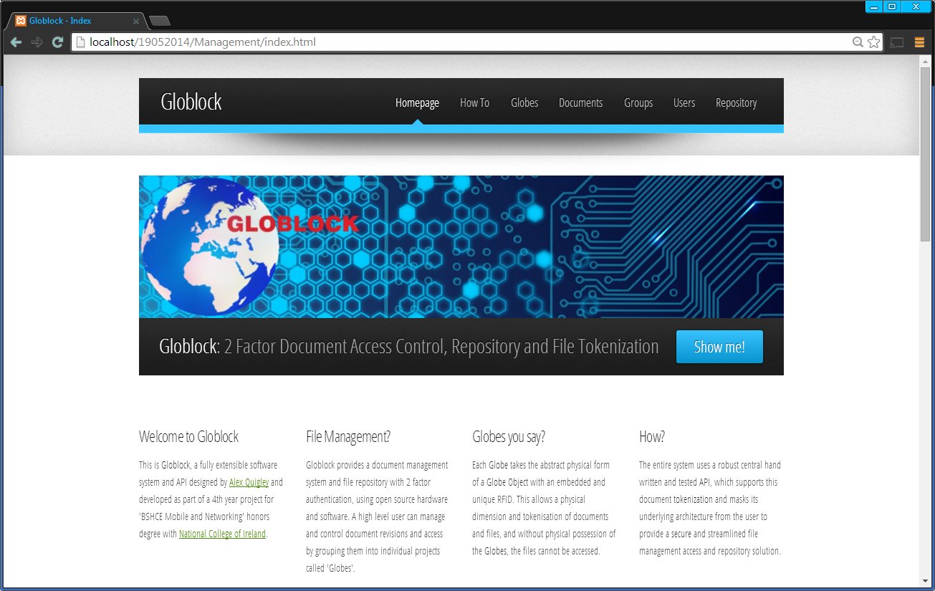

The management website should be fairly straightforward and easy to use.

|  |  |
| --- | --- |
| Globes The globes pages allow globes to be added and also list current globes that are active on the system.  To add a new a globe enter a name and a description and click submit. |  |

|  |  |
| --- | --- |
|  | Documents Documents can be created and uploaded here, with a table of all documents currently active on the system.  To add a new document, enter a document name and a description and then select a file from the file open dialog, then click submit. |

|  |  |
| --- | --- |
| Groups User groups can be created and once again groups already added to the system can be viewed in the table also.  Enter a group name and a description and click submit, to add a new group. |  |

|  |  |
| --- | --- |
|  | Users User can be added to the system by entering the required details, and selecting settings such as User Tpe, (super/regular) and Primary group. Once all the fields have been populated, simply click submit. |